Appendix C: The Next Generation Science Standards (NGSS)


In 2010, the National Academy of Sciences, Achieve, the American Association for the Advancement of Science, and the National Science Teachers Association embarked on a two-step process to develop the next generation science standards (NGSS). In April 2013, the NGSS were released for states to consider adoption.
The Next Generation Science Standards (NGSS) are distinct from prior science standards in three essential ways.
- Performance. Prior standards documents listed what students should “know” or “understand.” These ideas needed to be translated into performances that could be assessed to determine whether or not students met the standards. Different interpretations sometimes resulted in assessments that were not aligned with curriculum and instruction. The Next Generation Science Standards have avoided this difficulty by developing performance expectations that state what students should be able to do in order to demonstrate that they have met the standard, thus providing the same clear and specific targets for curriculum, instruction, and assessment.
- Foundations. Each performance expectation incorporates all three dimensions from the National Research Council report A Framework for K-12 Science Education (Framework)—a science or engineering practice, a core disciplinary idea, and a crosscutting concept.
- Coherence. Each set of performance expectations lists connections to other ideas within the disciplines of science and engineering and with Common Core State Standards in English Language Arts/Literacy and Mathematics.

Disciplinary Core Ideas
Disciplinary core ideas have the power to focus K–12 science curriculum, instruction, and assessments on the most important aspects of science. To be considered core, the ideas should meet at least two of the following criteria and ideally all four:
- Have broad importance across multiple sciences or engineering disciplines or be a key organizing concept of a single discipline;
- Provide a key tool for understanding or investigating more complex ideas and solving problems;
- Relate to the interests and life experiences of students or be connected to societal or personal concerns that require scientific or technological knowledge;
- Be teachable and learnable over multiple grades at increasing levels of depth and sophistication.
Disciplinary ideas are grouped in four domains: the physical sciences; the life sciences; the earth and space sciences; and engineering, technology and applications of science.
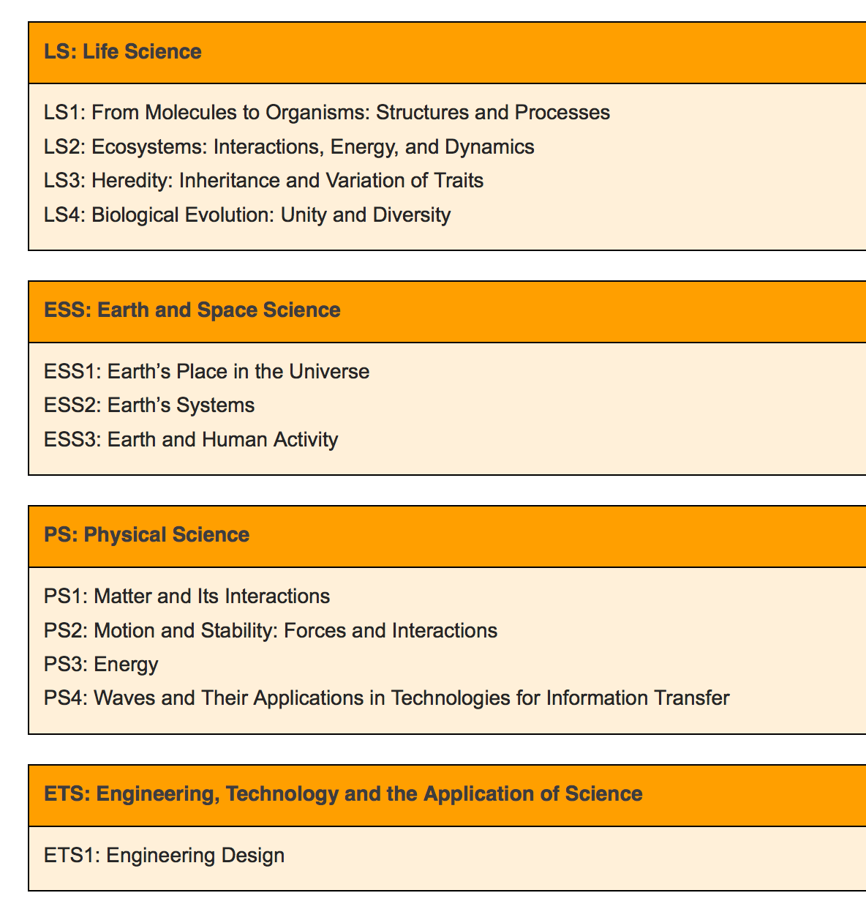
The NGSS are summarized at http://standards.nsta.org/AccessStandardsByTopic.aspx. Each topic can be expanded to go into more depth in each area. Summaries are shown below:

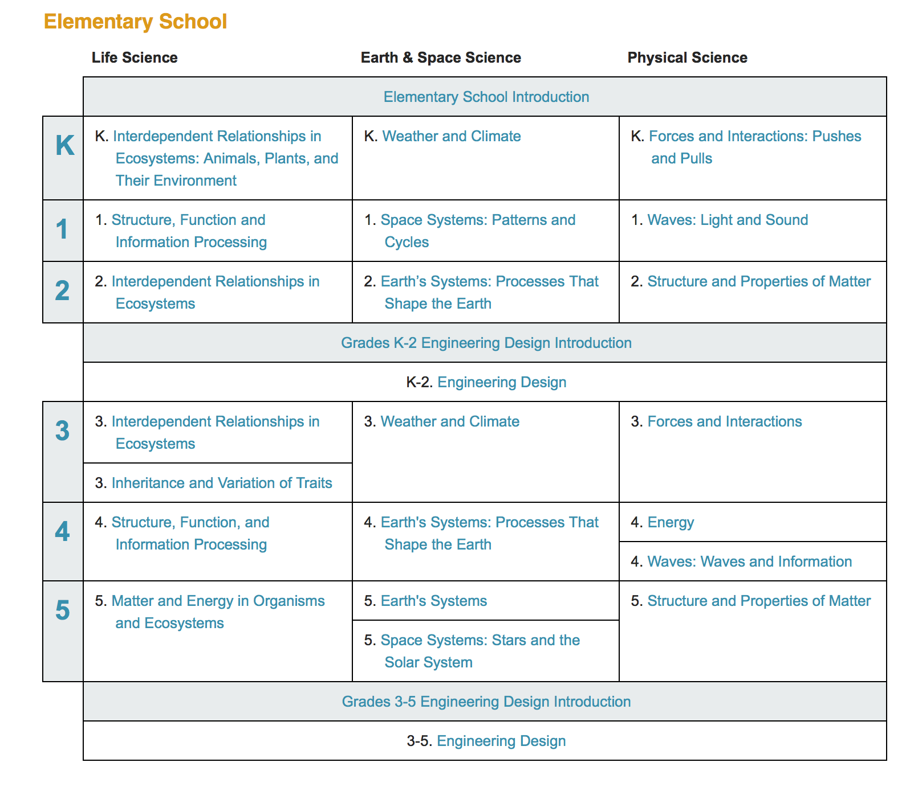
Let’s now expand one specific area: K-2 Engineering Design
Children seem to be born with a creative urge to design and build things. Often it takes little more than the presence of raw materials to inspire children to imagine and create forts and dollhouses from cardboard boxes and sandcastles from moist sand near the water’s edge. The task for the primary school teacher is to channel this natural tendency by helping students recognize that creative energy can be a means to solve problems and achieve goals through a systematic process, commonly referred to as engineering design. Although engineering design is not a lock-step process, it is helpful to think of it in three stages—defining the problem, developing possible solutions, and determining which best solves the problem.
Defining the problem begins in kindergarten as students learn that a situation people want to change can be thought of as a problem that can be solved. By the time they leave second grade students should be able to ask questions and make observations to gather information about the problem to they can envision an object or a tool that would solve it.
Developing possible solutions naturally flows from the problem definition phase. One of the most challenging aspects of this phase is to keep students from immediately implementing the first solution they thing of and to think it through before acting. Having students sketch their ideas or make a physical model is a good way to engage them in shaping their ideas to meet the requirements of the problem.
Comparing different solutions may involve testing each one to see how well it solves a problem or achieves a goal. Consumer product testing is a good model for this capability. Although students in the primary grades should not be held accountable for designing controlled experiments, they should be able to think of ways of comparing two products to determine which is better for a given purpose.
Connections with the other science disciplines help students develop these capabilities in various contexts. In kindergarten students are expected to design and build simple devices. In first grade students are expected to use tools and materials to solve a simple problem and test and compare different solutions. In second grade they are expected to define more complex problems then develop, test, and analyze data to compare different solutions.
Let’s now look at one specific area: Third Grade Weather and Climate:

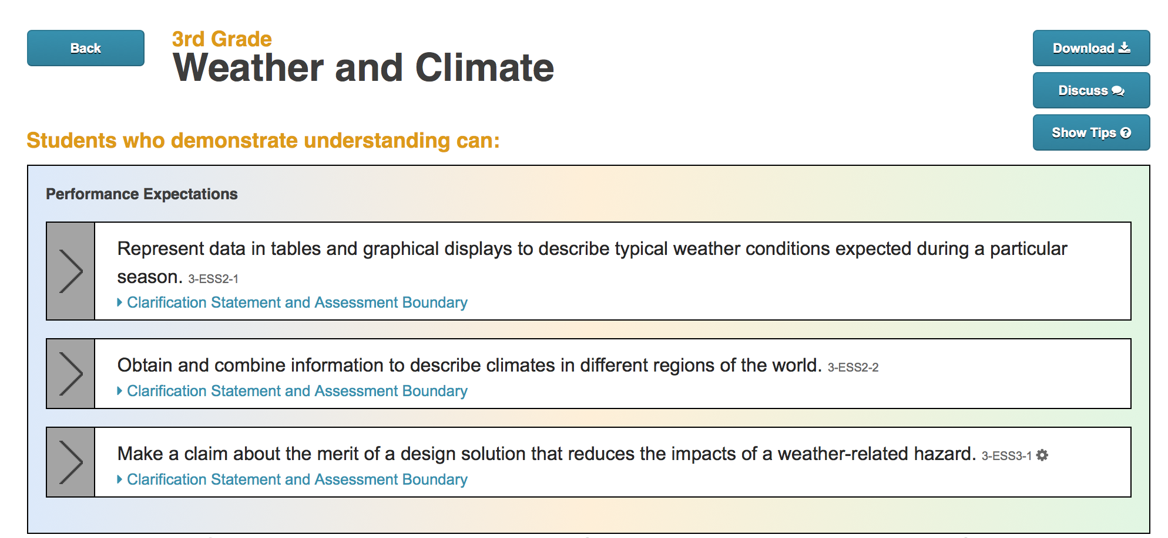

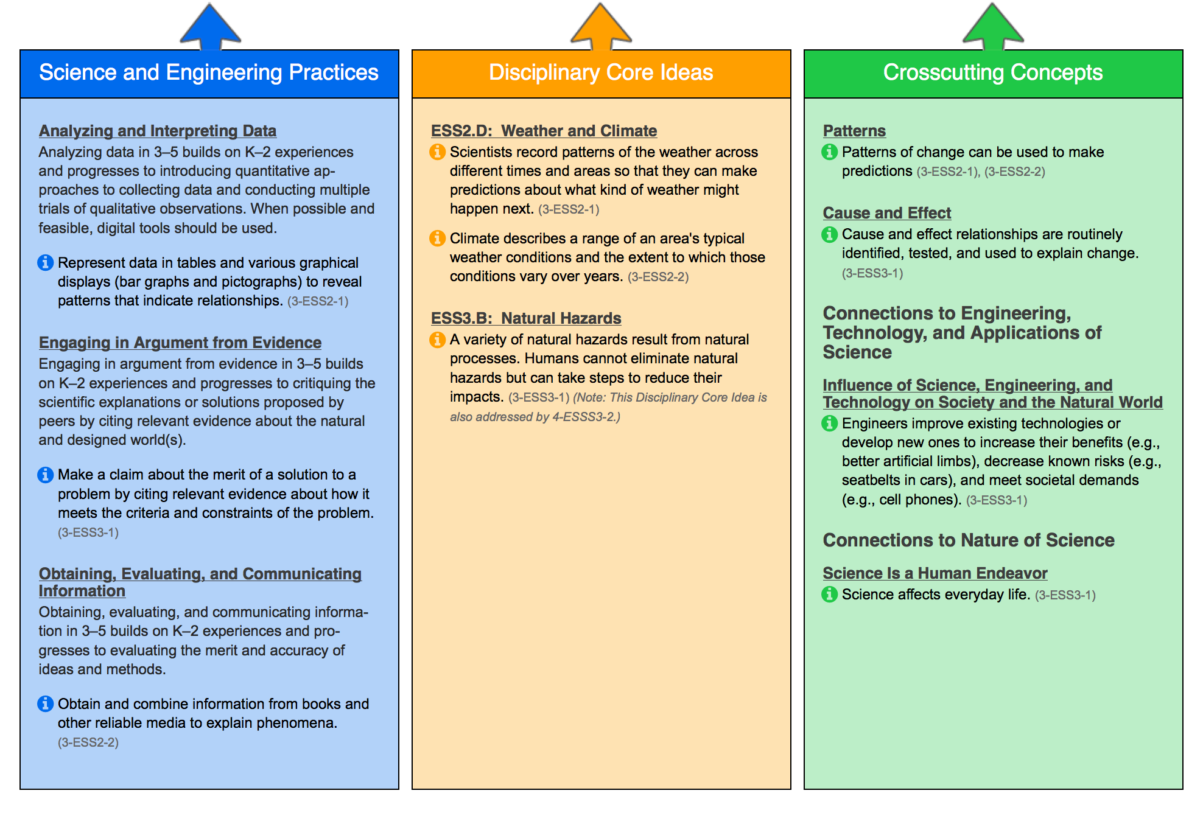

Finally, let’s look at the crosscutting concepts that have application across all domains of science. As such, they are a way of linking the different domains of science. These concepts need to be made explicit for students because they provide an organizational schema for interrelating knowledge from various science fields into a coherent and scientifically based view of the world.

